**iHotel**

Hotel Reservation System

Final Project Report

**Prepared by:**

Daniel Gallagher

Oksana Aleksandrovica

Eryk Gloginski

Donal McGinty

May 5th, 2023

Table of Contents

Introduction – 1000 Words 2

Application Design – 1000 Words 6

Reflections on teamwork – 1000 Words 12

Conclusions – 500 Words 14

Appendices 14

# Introduction – 1000 Words

**1. An overview of the project**

The "iHotel" project was a comprehensive and ambitious initiative that aimed to revolutionize the way customers search, compare, and book hotel rooms online. The project focused on developing a innovative platform that would provide an intuitive, user-friendly, and reliable experience to both new and returning customers.

One of the key goals of the iHotel website was to enhance the overall booking experience for customers by providing a streamlined and efficient process. The platform was designed to be simple to navigate, with a clean and modern interface that made it easy for users to search for hotels, compare prices, and book rooms with just a few clicks. The website's user-centric design also ensured that customers could access all the information they needed about their chosen hotel, including amenities, location, and reviews from other guests.

In addition to providing a seamless experience for customers, the iHotel project also aimed to simplify hotel management for hotel personnel. The platform provided an easy-to-use interface that allowed hotel staff to manage reservations, check-in and check-out guests, and track guest data. The system was designed to be highly scalable, making it suitable for hotels of all sizes and types, from small boutique hotels to large chain properties.

Overall, the iHotel project was a significant undertaking that aimed to revolutionize the online hotel booking industry. The platform's advanced features, user-friendly design, and focus on customer satisfaction and hotel management made it a truly innovative and game-changing solution.

**2. Here are some additional details that could be included in the functional specifications:**

One of the key features of the iHotel platform is its real-time room availability functionality, which allows customers to search for and book rooms based on their chosen dates. The system is designed to be intuitive and user-friendly, enabling customers to find the right room quickly and easily for their needs.

As customers search for available rooms, the system will automatically update the room inventory to reflect the latest availability information. This ensures that customers always have access to the most up-to-date information and can make informed decisions about their booking.

In addition to room availability, the iHotel platform also provides a range of other features and functionality to enhance the customer experience. For example, customers can add extras to their booking, such as room service to make their stay even more enjoyable.

Customers can also create their own account within the system, allowing them to easily manage their bookings, view their bill, and see the price for their stay in the hotel and any additional extras they have selected. This personalized approach helps to build trust and loyalty with customers and provides them with a convenient and streamlined experience.

To further enhance the customer experience, the iHotel platform also enables customers to register for the system if they are not yet registered.

Overall, the iHotel platform provides a comprehensive and user-friendly booking experience that is designed to meet the needs of both customers and staff members. By leveraging real-time availability data, personalized account features, and a range of extras and add-ons, the platform can deliver a high level of convenience, value, and satisfaction to customers.

Payment Gateway Integration: The iHotel platform will integrate with a payment gateway to allow customers to make secure online payments for their bookings. The payment gateway will support multiple payment methods, including credit cards, debit cards, and online payment systems.

Social Media Integration: The platform will also include social media buttons to make it easy for customers to follow the hotel on social media.

**3. Technical specifications:**

The iHotel platform was developed using a range of innovative technologies and tools to ensure that it is reliable, secure, and scalable. Here are some additional details that could be included to make the technical specifications look smarter:

PHP Framework

JavaScript Libraries

Database Management

By including these additional details in the technical specifications, stakeholders can have a better understanding of the technology stack used to develop the iHotel platform and the benefits it provides in terms of performance, scalability, and security.

In addition to providing customers with a user-friendly booking experience, the iHotel platform is also designed to streamline operations for staff members. Staff members have access to a range of features and functionality that allows them to efficiently manage bookings, add extras, and check guests in and out.

When a new booking is made, staff members can review the booking details to ensure that everything is accurate and up to date. If changes need to be made, staff members can easily modify the booking or add extras to enhance the guest experience.

As guests arrive at the hotel, staff members can quickly and easily check them in using the iHotel platform. This process is designed to be seamless and efficient, allowing guests to get settled into their rooms as quickly as possible. Similarly, when guests are ready to check out, staff members can use the platform to process their payment, print a receipt, and provide any necessary information about their stay.

To further enhance their experience, staff members can also log in to the system to access a range of additional features and functionality. For example, they can view detailed guest information.

Overall, the iHotel platform provides staff members with a powerful and intuitive set of tools for managing bookings, adding extras, and checking guests in and out. By streamlining these processes and providing staff members with real-time access to vital information, the platform helps to improve efficiency, reduce errors, and enhance the overall guest experience.

**4. Summary of conclusions i.e., did the conclusion of the project correspond with or discord with the original project goals.**

In summary, the iHotel platform is a comprehensive and user-friendly system designed to enhance the booking experience for customers and streamline operations for staff members. The system leverages a range of features and functionality, including real-time room availability, personalized account features, and a range of extras and add-ons, to provide customers with a convenient and satisfying booking experience. At the same time, staff members can efficiently manage bookings, add extras, and check guests in and out using the platform, improving efficiency, and reducing errors. Overall, the iHotel platform represents a powerful tool for hotels looking to enhance their online presence and provide a better booking experience for their customers.

**5. Role assumed by team members.**

**Oksana Aleksandrovica:**

Oksana Aleksandrovica played a role in the development of the iHotel platform, contributing to a range of some features and functionality. As the designer, Oksana was responsible for creating a user-friendly and intuitive interface that would appeal to customers and make the booking process as simple and straightforward as possible.

One of Oksana's key contributions was the overall design of the website. She carefully selected fonts, colours, and other design elements to create a clean, modern look that would appeal to customers and help to establish the iHotel brand. She also worked closely with the development team to ensure that the design was implemented correctly, and that the user experience was seamless and intuitive.

In addition to her design work, Oksana was also responsible for developing the login and logout system for staff and customers. This involved creating secure login pages and integrating them with the underlying database to ensure that customer and staff information was stored safely and securely. To make this goal better looking and the code look cleaner and easier Eryk Gloginski gave good advice to Oksana and helped with code.

Another feature that Oksana contributed to be the customer registration system. She worked closely with the development team to create a simple and intuitive registration process that would allow customers to sign up quickly and easily, without having to navigate through a complex set of forms or procedures.

Finally, Oksana was responsible for developing the customer-facing aspects of the platform, including the room availability, and booking system, as well as the rating and review system. She worked closely with the development team to ensure that these features were implemented correctly and that customers could easily search for available rooms, book their stay, and leave feedback about their experience.

**Daniel Gallagher:**

As a key Back-end Developer member, of the iHotel project, I played a pivotal role in developing and implementing the core functionality for booking reservations on the iHotel platform. My expertise in PHP programming and commitment to delivering high-quality code were instrumental in ensuring the seamless integration of booking features on the platform.

My primary responsibility was to create a robust booking system that catered to both registered customers and first-time users. Through my efforts, I managed to design a streamlined booking process that allowed users to reserve hotel rooms efficiently and effortlessly. When a first-time user made a reservation, the system automatically registered them as a customer on the hotel website, further enhancing the user experience and fostering customer loyalty. I also had some help with Oksana displaying the room images on the room selection page.

To achieve this, I developed PHP pages that encompassed the different stages of the booking process, such as room selection, reservation details and first-time user registration etc. Also, my contributions to the project were not only limited to my technical skills. As a team player, I actively particularly in brainstorming sessions, providing insightful suggestions to improve the overall functionality and design of the platform.

**Eryk Gloginski:**

Eryk Gloginski was an integral part of the iHotel platform’s development, contributing to various features and functionalities regarding the front-end and back-end. Eryk was the first to suggest the use of PHP for the website as it is extremely easy to store session variables in PHP. Eryk’s expertise in PHP and SQL was instrumental in cleaning up the messy codebase in version 1, making it more accessible for other team members to contribute and going as far to even create a template file that everyone would then be using.

Additionally, Eryk implemented the registration system, which allowed customers to sign up quickly and easily, and he also introduced a basic login and logout concept that was further developed by Oksana Aleksandrovica, who used it to create separate login pages for the customers and staff members. Eryk was also responsible for displaying the customer’s and staff member’s names at the top of the website when they were logged in in their respectable hubs.

In version 2, Eryk created the functionality that allowed staff members to add rooms and their details into the database. He additionally collaborated with Oksana on the functionality for managing Extras that the customers would be able to order in the further version of the team project.

Finally, in version 3, Eryk added a functionality that allowed registered customers to request extras, a valuable addition to the website’s overall functionality which was further developed by Donal McGinty. At the end of Eryk’s work, he decided to take a break and focus on other things, and let his team take care of everything, but he was always available to attempt to help if someone was stuck on something.

**Dónal McGinty:**

Dónal McGinty was a key full stack developer for the iHotel management project, contributing to different stages of the development process. Donal’s experience with PHP, JavaScript and SQL allowed him to create functional and efficient code to integrate the various features he was assigned to complete.

In version one Dónal was assigned to create a prototype booking page Gui that would display a list of the available rooms stored in the database, as well as select the check in and check out dates. This was later revamped and added into the reservation pages developed by Daniel.

In version two Dónal was assigned to create a check-in-checkout system. This would allow the receptionist to check customers in and out and update the database accordingly, with error handing to make sure it was only the appropriate dates.

In version three Dónal was assigned to update the systems form validation and error handling. This largely involved reworking forms to no longer allow any text as well as fixing various bugs still in the system and helping other team members to bugfix their work.

For the final version, Dónal was assigned to revamp the extra system to allow the staff to update the list of extras they offered to customers. This involved updating the hotels database to have to have a new table for available extras and adding delete, update and add crud features to the manage extras page. Dónal was also involved in some extra input and error validation, as well as helping merge Oksana’s new review table into there database.

# Application Design – 1000 Words

1. **Summary breakdown of the major tasks of the project, the time spent on each and the team members involved. Each team member should provide evidence of their contribution.**
   1. **Design and development of the user** **interface** (UI) - Oksana Aleksandrovica (65 hours)

Oksana focused on creating an intuitive and visually appealing user interface. She was responsible for the overall design of the website, creating wireframes, mock-ups, and interactive prototypes. Oksana also developed the login and logout system, the customer registration system, and worked on customer-facing aspects of the platform, including the room availability, booking system, and the rating and review system. She collaborated with other team members to implement the design correctly and ensure a seamless user experience.

* 1. **Backend development for the booking system and process -** Daniel Gallagher (70 hours). Daniel built the server-side logic for processing room bookings, user registration, and other core functionalities using PHP and MySQL. He designed a streamlined booking process, created PHP pages for various stages of the booking process, and participated in brainstorming sessions to provide suggestions for overall functionality and design improvements.
  2. **Implementation of room management and functionalities** - Eryk Gloginski (53 hours). Eryk contributed to various front-end and back-end features and functionalities, such as suggesting the use of PHP for the website and helping clean up the codebase. He implemented the registration system, the basic login and logout concept, and was responsible for displaying the customer's and staff member's names at the top of the website when they were logged in their respective hubs.
  3. ??- Donal McGinty (47 hours).

1. **Functional requirements described and listed --- include UML use case (use case descriptions as an appendix). Evaluation of the technical aspects of the project i.e. what level of functionality of the project was achieved/implemented.**
   1. **User interface:** The system features an easy-to-use interface for customers to search for and book rooms, manage their account settings, and leave reviews, as well as for hotel staff to manage reservations and customer information.
   2. **Real-time room availability and booking:** The system displays available rooms and their prices in real-time, handling multiple room types and pricing structures. Customers can easily look at and book rooms through the user-friendly interface.
   3. **User account creation and management:** The system allows customers to create profiles, store their personal information, such as contact details and and manage their account settings.
   4. **Hotel staff reservation management:** The system enables hotel staff to view, edit, and cancel reservations, manage customer information, check customers in and out, and add extras to reservations.
   5. **Payment gateway integration:** The system integrates with an online payment processing system that supports methods such as credit card and debit card. It also includes dummy payment processing for testing purposes.
   6. **Review:** The system allows customers to leave reviews on the hotel, enabling potential customers to make informed decisions based on others' experiences and feedback.

**Implemented Functionalities:**

* + 1. Customers can register.
    2. Customers can log in and out.
    3. Customers can edit their details.
    4. Receptionists can log in and out.
    5. The name of the customer/receptionist is displayed at the top of the page.
    6. Receptionists can add and update rooms and their details.
    7. Customers can make reservations (email customer details of reservation status).
    8. Receptionists can check customers in and out.
    9. Receptionists can add extras to reservations.
    10. Customers can view their reservations.
    11. Customers can receive a receipt for their reservation.
    12. The website is properly styled.
    13. Customers can add extras to a reservation through the customer hub.
    14. Customers can navigate the pages while still being logged in.
    15. Input validation is implemented in all forms.

1. **Technical description of project:**
   1. **Hardware requirements.**
      1. A web server with PHP support
      2. Sufficient storage space for database and website files
   2. **Software requirements.**
      1. PHP 7.x or higher
      2. MySQL database
      3. Using SQL, PHP, CSS, HTML and JavaScript.
2. **Database design**
   1. **ERD/Class Diagram**

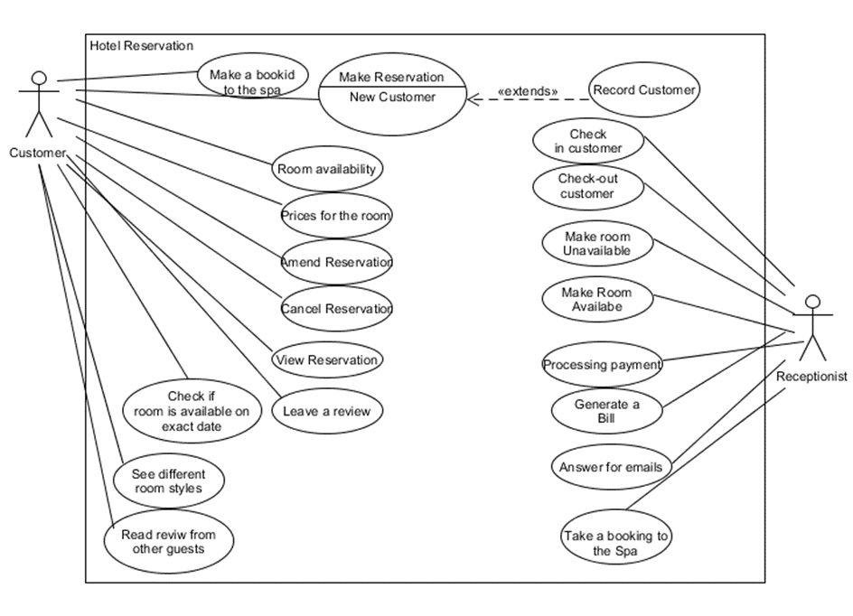

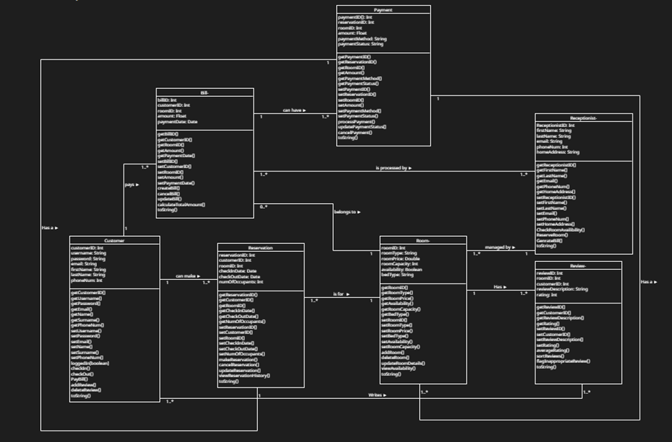

* 1. **Tables**

1. **Methodology (SDLC): rationale and implementation of the approach taken.**

The project was developed using the Agile methodology, which allowed the team to iteratively develop and improve features while maintaining flexibility to respond to changing requirements. The team held regular meetings to discuss progress, identify issues, and determine priorities for the next development cycle.

1. **Implementation issues - technical choices, coding styles, changes, risks, and weaknesses.**
   1. **Technical choices:**
      1. The team decided to use PHP and MySQL for backend development due to their compatibility and wide adoption in web development. This choice facilitated efficient server-side programming and database management.
      2. For frontend development, the team used HTML, CSS, and JavaScript to build an interactive and visually appealing user interface.
   2. **Coding Styles:**
      1. The team adhered to best practices for coding, ensuring readability, maintainability, and consistency throughout the project. They used meaningful variable names, proper indentation, and code comments to make the code easier to understand and debug.
   3. **Changes:**
      1. During the development process, the team made several changes to the initial design and functionality to better meet user needs and improve the overall user experience. These changes included the addition of user profile management, the ability to add extras to reservations through the customer hub and implementing input validation for all forms.
   4. **Risks:**
      1. One significant risk faced during the project was the potential for unauthorized access to sensitive customer and hotel information. To mitigate this risk, the team implemented security measures such as password hashing, input validation, and secure session management.
      2. Another risk was the system's scalability, as it needed to handle a growing number of users and reservations. The team addressed this by designing the database and server architecture to support the addition of resources as needed.
   5. **Weaknesses:**
      1. The email functionality implemented in PHP proved to be challenging due to limitations in server configurations and email delivery reliability. The team addressed this by providing customers with the option to see their reservation bill information as a text file.
      2. The user interface, while visually appealing and easy to use, might not be fully accessible for users with disabilities. Future improvements could include implementing accessibility features to better serve a wider range of users.
      3. The current payment gateway integration supports credit cards and debit cards but does not include support for alternative payment methods such as digital wallets or cryptocurrencies. This limitation may be addressed in future updates to broaden the available payment options for customers.
2. **Description of main technical issues/problems, include code snippets and explanations if appropriate.**

Integrating email functionality in PHP proved to be challenging due to limitations in server configurations and email delivery reliability. To address this issue, Daniel implemented a feature that allowed customers to download their reservation bill information as a text file, providing a convenient and user-friendly alternative.

1. **Include test cases as an appendix.** 
   1. **Test Case 1 - Register a new user:**
      1. **Input:** Valid email, password, and other required information.
      2. **Expected Output:** User account created and stored in the database.
   2. **Test Case 2 - Login with valid credentials**
      1. **Input:** Valid email and password
      2. **Expected Output:** Successful login and redirection to customer hub.
   3. **Test Case 3 - Login with invalid credentials**
      1. **Input:** Invalid email and password
      2. **Expected Output:** Error message displayed, prompting the user to try again.
   4. **Test Case 4 - Check room availability**
      1. **Input:** Desired check-in and check-out dates
      2. **Expected Output:** Display of available rooms for the selected date range.
   5. **Test Case 5 -** **Display available rooms based on user-selected check-in and check-out dates:**
      1. **Input:** Desired check-in and check-out dates, followed by clicking the 'see Availability' button.
      2. **Expected Output:** A list of available rooms for the specified date range is displayed, allowing the user to choose and proceed with booking.
   6. **Test Case 6 - Manage reservations as hotel staff:** 
      1. **Input:** Hotel staff login credentials, reservation details to modify
      2. **Expected Output:** Ability to view, modify, or delete reservations.
   7. **Test Case 7: Check-in and Check-out with an unavailable date range.** 
      1. **Input:** Check-in and check-out dates that overlap with an existing reservation for the selected room
      2. **Expected Output:** Error message displayed, prompting the user to select another check-in date and check-out date.
   8. **Test Case 8: Update user account information** 
      1. **Input:** New email, password, or other personal details.
      2. **Expected Output:** Updated user account information and its updated and stored in the database.

# Reflections on teamwork – 1000 Words

**Q1. How were decisions made by the team?**

Our team made decisions through a combination of mandatory leadership swaps and voting. Every three weeks, a new team leader was appointed, giving each member a chance to lead the team. However, the ultimate decision-making process was determined by voting, with everyone having an equal say. This approach to decision-making not only allowed for everyone's voices to be heard but also promoted teamwork and collaboration. By giving each team member an opportunity to lead and participate in the decision-making process, the team could foster a sense of shared ownership and accountability for the project's outcome.

**Q2. Did all the team members contribute equally to the development of the project?**

Our team members did not contribute equally to the development of the project. Some team members contributed more at the beginning of the project, while others contributed more towards the end. This uneven distribution of contributions is common in teamwork, and it can be attributed to a variety of factors, such as individual strengths and weaknesses, time constraints, or personal circumstances. However, it is important to note that this does not necessarily indicate a lack of commitment or effort from any team member. Rather, it is the responsibility of the team to ensure that all members are given the opportunity to contribute to the best of their abilities, regardless of when this contribution takes place. By recognizing individual strengths and weaknesses and working collaboratively, the team can ensure that all members are valued, and the project's outcome is successful.

**Q3. How much communication occurred during the project? What different forms did it take?**

Q3. Initially, communication among the team members war poor as we were only able to communicate with each other at the college campus itself, which if it continued, it could have negatively impacted the project outcome. However, Oksana suggested to create a Snapchat group chat, which all the members were satisfied with, except for one member, who did not have the app. Eryk then suggested using Discord, which did not only provide a platform for communication but also allowed for the sharing of files. This alternative solution shows how effective teamwork requires open communication and the willingness to adapt different circumstances.

**Q4. Describe one technical problem that was overcome by the team.**

Q4. The reflections on teamwork regarding overlapping work emphasize the importance of utilizing the appropriate tools to enhance collaboration with other team members. Our team has used OneDrive to store the files, which required manual comparison of different versions of the project. However, if we had used GitHub, which is designed for collaborative work, we could have avoided the time-consuming task of comparing different versions of the same project. GitHub enables multiple people to work on the same project and make changes without conflicting with each other. Our team’s experience highlights how selecting the appropriate tools can streamline collaboration, minimize overlapping work and lead to a more efficient project outcome.

**Q5. Describe one team problem that was overcome by the team.**

One team problem that was overcome by the team was the integration of email functionality in PHP. Initially, the team faced challenges in implementing this feature due to limitations in server configurations and email delivery reliability. To address this issue, the team collaborated and came up with an alternative solution. Daniel, a team member, implemented a feature that allowed customers to see their reservation bill information as a text file. This provided a convenient and user-friendly alternative, and it demonstrated the team's ability to work together to find creative solutions to overcome obstacles.

**Q6. How does working on a team project compare to working individually on a project?**

Working on a team project compared favourably to working individually on a project. When working alone, an individual can get stuck on a problem or task and may have limited resources or ideas to help overcome the issue. However, working as part of a team project provides an opportunity to collaborate and leverage the skills and experiences of other team members. By working together, team members can share ideas, problem-solve together, and support each other when obstacles arise. This collaborative approach not only helps to overcome challenges but can also lead to better outcomes by harnessing the diverse perspectives and strengths of the team.

**Q7. What were the strengths of the team. Q8. What were the weaknesses of the team.**

**Strengths:**

The strengths of the team primarily lay in their diverse skill set and adaptability. The team members brought different skills and expertise to the project, allowing for a comprehensive approach. Furthermore, their adaptability was evident in their embrace of the Agile methodology, enabling them to respond effectively to changing requirements and iteratively develop and improve features throughout the project.

**Weaknesses:**

The weaknesses of the team included limited experience with certain technologies, time management issues, and accessibility concerns. Some team members faced challenges implementing specific features due to their lack of experience with certain technologies, while others struggled to balance project workload with other commitments. Additionally, accessibility considerations were not fully addressed in the initial design and development, which may limit the usability of the system for users with disabilities.

**Q9. On reflection after the fact, how could the team be improved to improve performance and avoid problems? If you were to start again, what would you, as a team, change?**

Upon reflection, there are several key areas where our team could improve its performance and avoid problems. First, enhancing communication by establishing more frequent and structured channels, such as regular check-ins and progress updates, would help to ensure smoother collaboration. Second, implementing more rigorous time management strategies, including setting milestones and deadlines for specific tasks, would contribute to the timely completion of project phases and minimize potential delays. Third, conducting regular risk assessments to identify potential issues or bottlenecks and devising appropriate mitigation strategies would enable the team to proactively address challenges before they become critical problems. Lastly, maintaining thorough documentation of the project, including coding standards, design decisions, and feature specifications, would facilitate easier knowledge sharing among team members and enable smoother handovers when necessary. Implementing these improvements would lead to a more efficient and successful project outcome if we were to start again.

# Conclusions – 500 Words

**Conclusion**

In conclusion, the iHotel project, a hotel reservation system, was a valuable learning experience for the team, allowing them to develop and hone their teamwork and project management skills. The team's decision-making process, which involved rotating leadership and voting, fostered a sense of shared ownership and accountability for the project's outcome. While not all team members contributed equally throughout the project, their combined efforts ultimately led to a successful result.

Effective communication and adaptability were crucial factors in overcoming initial challenges, such as poor communication and technical issues. By embracing alternative platforms, like Discord, and finding creative solutions to problems, the team demonstrated their resilience and commitment to the project. The benefits of working on a team project, as opposed to individually, were evident in the team's ability to collaborate, share ideas, and leverage diverse skills to overcome obstacles and achieve a high-quality outcome.

The strengths of the team, such as their diverse skill set and adaptability, were counterbalanced by weaknesses in specific technical expertise, time management, and accessibility considerations. Reflecting on these aspects, the team identified several areas for improvement, including enhanced communication, time management, risk assessment, and documentation. By incorporating these changes, the team would be better equipped to handle future projects and achieve even greater success.

Overall, the iHotel project was a successful endeavour that taught valuable lessons about teamwork, collaboration, and project management. By examining the strengths and weaknesses of their approach, the team can apply these insights to future projects, ultimately leading to more efficient and effective outcomes.

# Appendices

* **UML diagrams.**
* **Journal entries.**
* **Snippets of code if noteworthy.**